Meeting Minutes
Davidson Creek Elementary School Council
September 10, 2019 6:00pm
Board Members
Melissa Presse, Chair | Ashley MacInnis, Vice Chair | Karli Butler, Secretary
|Stephanie Peterson, Communications

Meeting Minutes – IN DRAFT

Chair welcomed attendees and guests and gave a Treaty 6 Acknowledgment

The Secretary took attendance:

Parent Council Executive: Melissa Presse, Chair, Ashley MacInnis, Vice Chair, Karli Butler, Secretary, Stephanie Peterson, Communications Office – All Present

Parent Council Members: 16 additional parents attended the meeting

DCE Staff: Kaye Schindeler, Principal, Murray Howell, Assistant Principal, Mrs. Marlis Marler, Assistant Principal/Counselor, Jennifer Mikitka, Amy Rice – Present

Guests: Annette Hubrick, Elk Island Public School Division Trustee

Attendees each spoke introducing themselves

Chair review of the agenda there were no additions or deletions, meeting proceeded

The Chair asked for approval of minutes of June 10, 2019, AGM
- Motion was carried by – Keri H., and seconded by, Courtney M.

A brief discussion took place about presenting the minutes, of the previous meeting earlier than one to two days before the meeting they are to be approved at.

The Chair confirmed the School Council’s Operation Procedures states meetings minutes are to be completed 5 days after a School Council meeting. The September 10, 2019, meeting minutes will be posted well in advance of October’s meeting.

ACTION: The Secretary will send the Communication Officer a DRAFT of the minutes to post on Facebook 5 days after Council meetings.

2019-09-10 12:28 PM In DRAFT Page | 1OUS
INESS
Sizzler Recap – Jennifer Mills
Jennifer M. reported the Summer Sizzler, based on attendance numbers and feedback collected the event was a success and although the weather caused some issues this was not a considered a deterrent by those who participated.

Jennifer M. reported on the experience gained by doing this event for the first time and what the event planning team could be more aware of for future events.

Jennifer M. provided some direct feedback/comments. See quoted comments below:
- “Cotton candy should be in bags not cups”
- “Maybe move the food trucks closer to the front door of the school. Perhaps the other parent parking lot instead of the staff parking lot.”
- This lead to a brief discussion with meeting participants on where the placement of the food trucks should be. The issue was tabled for further discussion closer to the date of the 2020 Summer Sizzler.
- “1-2 more food trucks”
- “Set up the DJ closer to the main doors”
- “Have 2 balloon animal people and even have some premade balloon animals to handout”
- “A few more activities would be nice”
- “Maybe some tents setup in the field”
- “Concession was a great idea for cheaper options”
- “Roaming entertainers were excellent”
- “DJ was super fun to have by food trucks – party atmosphere”
- “Have 3-4 face painters”

Fat Burger Refund – Tara MacDonald:

This issue is outstanding from the previous school year (2018-2019). Tara M. reported the owner of Fat Burger would like to know what the refund he provided was going to be used for at DCE. The refund was approximately $1056.

Meeting participants discussed several options for the refund money. The Chair reminded participants to keep a focus on both School goals and Council objectives when considering options.

Discussions did not result in a final decision, but did narrow down the use of the funds to 3 possibilities.
- More bike racks – possibly placed behind the school
- Books; or
- Additional gym equipment

ACTION: Kaye S. will follow up on how much new bike racks will cost and report to SC with what costs need to be considered in order to move forward with this initiative.

ACTION: Erin W. will email a County representative to inquire if the school can pour concrete for more bike racks to be installed. Erin W. to advise Kaye S. and the Chair of any response(s) to her inquires.

ACTION: Tara M. to email/contact the owner of Fat Burger and advise him of the three possibilities under consideration for the refund money.

New Business

Principal Report – Kaye Schindeler
Kaye S. reported student numbers are slightly higher than expected and the school currently sits at 598 students.
The Provincial Government has not released and or approved any school operating budgets, which presents several challenges; however, things are moving forward and the school staff and leadership team remain positive.
The start of the school year with the students returning went very smoothly.
Kaye S. briefly introduced/spoke about the new teachers and the new assistant principal, Murray Howell, who have joined the school this year
Meeting participants discussed some of the various changes the provincial government is considering or implementing.
Kaye S. confirmed the government has provided little information to Alberta teachers and advised parents if they have questions or concerns to contact our local MLA.

As requested by meeting participants the contact information for Strathcona County’s MLA representative is to be included in the minutes, please see below:
Honourable Nate Glubish (UCP)
MLA for Strathcona-Sherwood Park
:
Constituency Office: Pending
Phone: 780.416.2492
Fax: 780.416.7093
Email: Strathcona.Sherwoodpark@assembly.ab.ca

Legislature Office
103 Legislature Building
10800 - 97 Avenue NW
Edmonton, AB
Canada T5K 2B6

Phone: 780.422.6880
Fax: 780.422.2496

Kaye S., along with meeting participants, discussed various minor issues that arose with the first day of school and children returning.
Although there were no major concerns Parents spoke about several options/possibilities to better facilitate entry into the school on the first day. All to do with helping students get to where they need to be.
ACTION: Council Chair asked for first day of school improvement suggestions to be tabled until June’s AGM so SC and the DCE leadership team can have this feedback closer to when it would need to be considered and implemented.

Chair Report – Melissa Presse

The chair spoke to recent changes made in the SC’s Operation Procedures. Please note the addition of: 7.0 Fund Requests and changes made to 10.0 Duties of Executive Member – Section 10.4, Fundraiser Liaison.

The chair and other meeting participants discussed how fund requests would work for the hot lunch program as these financial asks can happen more frequently than waiting for a SC meeting once a month.

Clarification was made at the meeting, through discussion, that any money which is a part of the current year’s approved budget for projects and initiatives are exempt from the Fund Request form/process. The Hot Lunch program was provided some operating expenses in the 2019/2020 budget. The Hot Lunch Committee can use these funds for their operations as they are pre-approved under the budget and, therefore, do not need to use the fund request process.

At this point in the meeting brief discussion took place among parent attendees about possible improvements to the healthiness of the Hot Lunch food menu.

It was suggested, through discussion, when considering healthy choices it might be better to have juice removed from the menu. While this suggestion was seen as understandable from a health standpoint, it was also met with opposition as the sale of juice contributed heavily to the fundraising aspect of the Hot Lunch program.

The SC Chair asked this discussion be tabled until October’s meeting as she would like the Hot Lunch committee to advise SC of what sort of revenue the juice generated for the program.

ACTION: The SC Chair will add Hot Lunch Menu Review as an agenda topic for October’s meeting. The Chair of the Hot Lunch Committee will provide how much the Hot Lunch Program made on Juice sales in the 2018/2019 year.

SC asked that the SC Operation Procedures include a section on “Budget” covering both the procedure to generate a budget and the allocation of funds through the approved budget process.

ACTION: The SC Secretary is to draft a new section of SC DCE Operation Procedures to include the allocation of funds via budget and budget creation standardization process.

The Chair asked if there was any issues/feedback to the current draft of the SC Operation Procedures changes. There were no further comments and the Chair asked SC to approve the Operation Procedures as it currently stands.
- The motion was carried by Courtney D. and seconded by Tara M.

The Chair then presented a DRAFT budget for the 2019/2020 school year, at the meeting, for review by meeting attendees. The budget expenses were was based on the actuals from the 2018/2019 school year.

The Chair reported the current draft budget was created based on confirmed projects and initiatives established in the 2018/2019 school year, which will be ongoing in the current school year. The Chair also verified the budget was reviewed by both SC Executive Members and Kaye S., DCE’s Principal, before it was presented at the meeting.

SC Parents reviewed handout of the budget at the meeting.

The Chair asked if there were any feedback/comments, questions or changes. There were no changes requested. The Chair moved to have the 2019/2020 DCE School Council Budget be approved
- The motion was carried by: Crystal W. and seconded: Chloe F. – This passed unanimously with all in favour.

COMMITTEE REPORTS

Wellness Committee: Sara Anderson and Deanna Bellamy

It was confirmed the first meeting of the year for the Wellness committee was scheduled for: Monday Sept 23 @ 6:30pm in the School Library, any and all Parents are welcome to attend.

Sara A. advised SC she was a part of the new Working with Active Kids Transportation Committee and the Wellness Committee will be focusing on this initiative.

The Wellness Committee reminded meeting attendees Orange Shirt Day is September 30. Orange t-shirts can be purchased online; or by cash only on Thursday Sept 12, at meet the teacher night.

Some of the parents asked for more information on the orange shirts. The Wellness committee gave a brief explanation that “Every Child Matters” is an awareness initiative about the effects of Residential Schools and the legacy they left behind. It was suggested for more in-depth information to visit the Orange Shirt Day website. It was asked that the minutes be updated with the correct web address provided here: http://www.orangeshirtday.org/

The Wellness committee was pleased to acknowledge that DCE had recently met with the AMA Patrol group and there are plans in the works to partner with them and their program. One of the Teacher’s present at a recent meeting provided feedback from the AMA Patrol visitors on how impressed they were with the number of kids who walked or biked to school.

This concluded the Wellness committee’s update

Moo Club – Andrea Levicki

Moo Club advised meeting attendees they still needed a volunteer to assist with some of the responsibilities at lunch time. A volunteer stepped forward at the SC Meeting

Andrea L. briefly discussed the milk program and how it works for volunteers

Pre-orders for milk will start Sept 16 and the program will go into effect on Oct 1, 2019

On a side note, outside of the committee update, Kaye S. commented DCE is also looking for lunch time supervisors as they are a bit short for volunteers as well.

There were no further updates from the Moo Club

NEW BUSINESS

Swimming Lessons – Stephanie Peterson

Stephanie P. confirmed she was in the final stages of compiling and concluding the 2019 swim program for grades 1-5.

It was mentioned that grade 6 classes would not be participating this year and the Kindergarten’s would be doing their own program later in the year.

Stephanie estimated that, with busing included, the cost per child was approximately $64.50, which was still slightly less than attending classes through the County.

Stephanie went on to confirm that Tuesdays and Thursdays would be swimming days. All swimming is in the morning, children get back just before lunch

Volunteers (men and women) will be needed to assist with children in the change rooms. Please contact Stephanie to volunteer.

We Day - Jennifer Mills
Jennifer M. asked SC to consider participating in We Day and becoming a “We School”

ADDED TO MINUTES post SC Meeting: “WE Schools is a year-long service-learning program that nurtures compassion in students and gives them the tools to create transformative social change.” https://www.we.org/we-day/

Wye School currently runs a version of this program for their elementary students

DCE School Leadership is reviewing this initiative

The chair asked for this request to be tabled until further discussions with more information can take place. Additionally, SC will give more time for School Leadership to review and consider.

The Chair then opened to discussion to all SC meeting participants about suggestions for other projects/events/initiatives that would benefit the school and the students. For example: movie nights, a school garden, more bike racks etc.

Sara suggested decorating competition among different classrooms. Perhaps decorate a window or door to a classroom with a prize for the best one.

Kaye S. responded that decorations on “entryways/exits” like windows and doors could be in violation of Occupational Health and Safety Policies for the school

ACTION: Kaye S. to follow up for October’s SC meeting if this activity is possible.

Kaye S. and other parents at the meeting suggested adding a school garden. Kaye S. along with Erin W. advised parents that Salisbury Greenhouse has a program DCE could access, which may provide a grant and or supplies for just this type of proposal. SC discussed all the benefits and possible spin offs from this initiative including composting and other environmental themed enterprises.

ACTION: Erin W. will follow up with Salisbury Greenhouse to see if DCE can access a grant or supplies-in-kind. Erin W. will provide follow up information at the next SC Meeting.

Trustee Report

Annette Hubick, Elk Island Public School Trustee attended the SC meeting as a guest and presented the SCHOOL COUNCIL REPORT, which has been provided in these minutes.

Annette briefly introduced herself. Annette was elected to the board in October 2017 and represents residents in urban Sherwood Park. She has two boys who attend school in Sherwood Park in grades 4 and 7.

Annette advised all meeting attendees that Elk Island Public School Division Board Meetings take place the 1st Wednesday of each month. Information about the meetings are posted online and all parents welcome to attend.

At the request of SC the following contact information for parents was added:

Annette Hubick
Trustee
Elk Island Public Schools
683 Wye Road
Sherwood Park, AB T8B 1N2
T: 780.417.8103
Annette.Hubick@eips.ca
www.eips.ca

A parent raised a question asked about the removal of the word “Public” in the Elk Island Public School Division name. Annette did not have much information on this issue yet. She did confirm this is a legal name change and would not affect the current branding/signage of the Davidson Creek Elementary School, nor, is it supposed to affect our tax dollars. More information from the provincial government is expected this fall.

Meeting Conclusion – Chair, Melissa Presse

The Chair thanked Annette for her update.

The Chair confirmed the following SC meeting dates for the rest of the 2019/2020 School year. Note these dates correspond with the 2nd Tuesday of every month.

- October 8
- November 19
- December 10
- January 14
- February 11
- March 10
- April 14

- May 12 (Final Meeting for Funding Requests)
- June 9 (AGM)

The DCE School Council Meeting adjourned at 7:37pm

SCHOOL COUNCIL REPORT
Presented by: Trustee Annette Hubick
September 2019

Over the summer
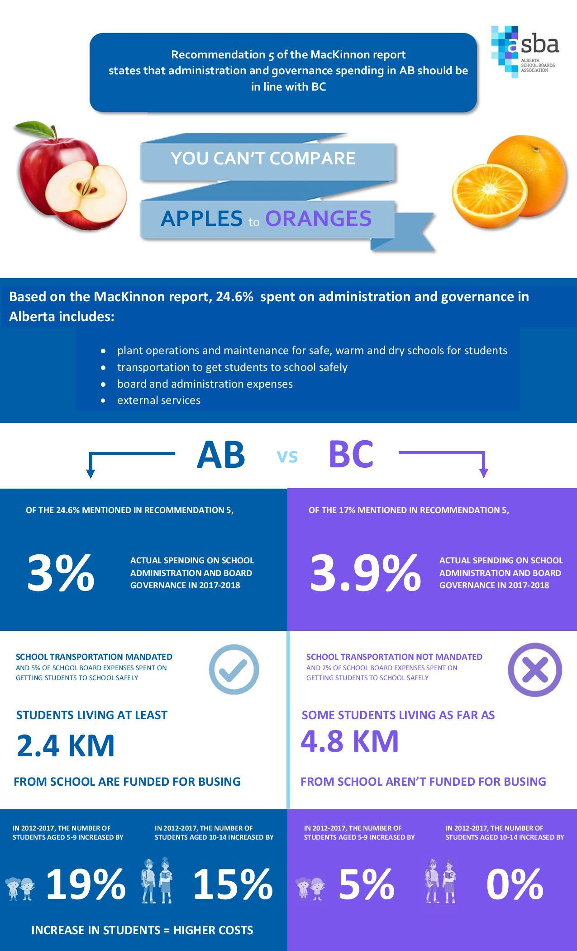
- I was one of two EIPS trustees who attended the Canadian School Boards Association Annual Congress in Toronto in July. It was a great professional development opportunity.
- I participated in various webinar/conference calls with Alberta Education regarding the Education Act and its regulations.
The Blue Ribbon Panel Report
Here are some important facts to give context to the report’s information that you may have heard about in the media.

Board Information
- August 29, 2019:
  - Trustees cooked and served a “Welcome Back” breakfast for Central office staff.
  - The board participated in our annual self-evaluation.
  - Board meeting:
    - the trustees re-elected Trina Boymook as Chair and Heather Wahl as Vice Chair of the Board of Trustees.
    - The Board approved the Trustee School Liaison Representative List for the 2019-20 school year. Several changes were made to Sherwood Park school assignments and I look forward to connecting with new school communities.
- I will be moving off the Advocacy and Teacher Board Consultation committees and onto the Policy Committee and Suspension/Expulsion Appeal Panel. The Policy Committee has a big workload ahead as we review and adapt policies through the lens of the Education Act.

Meeting with Education Minister
The board met with Minister of Education Adriana LaGrange and MLAs Jordan Walker and Nate Glubish on September 10th. Topics were:
- Overview of EIPS—our successes and our challenges
- The Education Act
- Budgeting
- Facility priorities (prior to the meeting, the Minister had toured Sherwood Heights with Board Chair Boymook).

School Fees – Clarification
What has actually changed:
- Boards are no longer required to have the administrative burden of submitting fees to the Minister for approval every quarter.
- The 5% cap has been lifted to allow for changes in costs, additions to program offerings, etc.
- Some of the rules around transportation fees however, more detail is needed, including what the funding will be.
What hasn’t changed:
- Boards are still not allowed to charge for supplies, i.e., what EIPS used to call its division-wide “Learning Resource Fee.”
- Fees can only be collected to cover actual costs. Administrative procedures are in place to deal with any fee surpluses.

Let’s connect
- Like my Facebook page: @hubickEIPStrustee
- Follow on Twitter: @annettehubick
- To ask questions, offer suggestions or voice concerns: Annette.Hubick@eips.ca

What do you want to hear about from your Trustee Liaison?
First Wednesday of each month is the School Division meetings, parents welcome. Annette encouraged parents to come
Blue Ribbon Panel report - Handout provided, see attached, Annette reviewed the handout
The board has just met with the Minister of Education. There were no infrastructure information shared and the Minister said the provincial budget would come out in about 6 weeks.
School fees were discussed - highlighted in attached handout
Some Rules around transportation are changing – highlighted in the attached handout
Contact and Social Media Contact was provided for Parents to reach out to Annette as our trustee

No further updates were provided.

