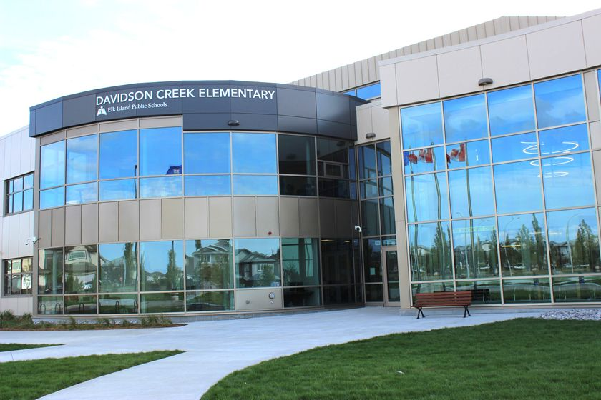**Meeting Minutes**

Davidson Creek Elementary School Council

**Meeting Date: November 16, 2023**

**Parent Council Executive Members:**

Lynn Walker, Chair (absent); Karli Butler, Vice Chair; Hannah Parker, Communications Liaison; Rochelle Reed, Secretary

**Guests and DCE School Representatives:**

DCE Staff: Helene Hewitt, Principal, Jay Robertson Vice Principal, Jenn Mikitka, Teacher

Public Trustee: Trina Boymook

Guests: N/A

Parent Representatives: We had 5 parent representatives in attendance

**DCE School Council Meeting MINUTES**

**Call To Order:** 6:42pm

**Treaty 6 Land Acknowledgement**

* Read by Vice Chair

**Call for Agenda Changes**

* No changes requested

**Approval of Agenda**

* Motioned: Robin B.
* Seconded: Candice A. / motion passed unanimously

**Call for Changes to Minutes**

* October and November Meeting Minutes will be presented for approval in January 2024’s School Council meeting.

**Public Trustee Report, Trina Boymook**

* The Superintendent is currently reviewing the additional information she requested to determine what her French Immersion secondary recommendation to the Board will be. The earliest that we could see this recommendation coming forward is the December 14 Board meeting. I will have a better idea of the timing of the recommendation coming forward will be December 7. Time will be allowed to ensure we have the best information in front of us to the best decision for the program and EIPS as a whole.
* School Assurance Reviews will be starting up next week. Davidson Creek will be held on November 7 at 9am at Davidson Creek. School Councils are encouraged to have representatives attend along with your school administration.
* The Board hosted the Education Critic and Sherwood Park MLA today. We arranged a few classroom visits at Davidson Creek and Bev Facey, to highlight class size and classroom complexity and it’s impact on outcome for students. Very productive meeting as we covered , Board autonomy, school construction, red tape, funding formula, high school CTS funding and Puff funding.

**Wellness Committee Report, Chair, Candice Abraham**

* Candice is in ongoing discussions/meeting with previous wellness chair to transition responsibilities and find out more information on how the pink shirt initiative was run in previous years by this committee.
* In the past the pink shirt initiative held an art contest, which included all the students across the school. The Wellness committed is looking to do something the same or similar in early 2024.
* Candice is in ongoing discussions/meetings with Sobeys to plan how to roll out a Healthy Snack Day in Spring 2024. Yet to be determined is how to efficiently provide an individual healthy snack to each student and what that snack will be. Preliminary discussions are strongly considering a snack that includes fresh fruit, but nothing is confirmed and this may change.
* Candice and Wellness Committee members met with DCE school councilors to identify opportunities for collaboration. One of their discussion topics focused on improving methods to display important family resources for easy access at the school.
* The Wellness Committee also took some parent feedback to School Counselors about possible opportunities to further support social skills improvement options especially for kids struggling in large social spaces like the playground.
  + It was discussed Considering small social group settings at recess that can support kids who are overwhelmed. Councilors suggested small structured supported areas on the playground that a parent volunteer could support.
  + Helen mentioned, through a past experience, she had worked with a group called Positive Playground and perhaps we could reach out to this group about possible additional options for social skill development/support
  + Discussion commenced about various options for playground social interaction supports

**Chair Report, Provided by Vice Chair, Karli Butler**

* *No November COSC update was provided.*
* Discussed possible communication improvement with parents/families/caregivers. Comms to these stakeholders is available through multiple channels, but these groups aren’t connecting as well with them as we would like. Group discussed possible new

channels and various options to better leverage existing channels to improve communication reach.

* Text messaging not an available option at this time, guided by policy outside of school’s prevue.

One suggestion was to physically post important weekly information on Mondays at the front of the school where children and parents gather to drop off and pick up. Like an external bulletin board with messages posted on it.

**DCE Admin Report. Helene Hewitt**

**Celebrations**

* Popcorn day was a hit! Thanks to the parent volunteers for making it a tasty day!
* We’ve had many parents volunteering in the building - so great to have support from the community.

**Demonstration of Learning & Report Cards :**

* Thanks to all for joining us in our Demonstration of Learning
* We had a variety of feedback on this event with some people sharing how much they enjoyed it and others not understanding what it was and therefore not attending and others expressing a preference for 10 minute interviews
* We will take the feedback and use it to inform how we approach the first round of conferences for 2024-25
* Next year, we will be having our kinder interviews in late November (separate from the rest of the grades) so that the teachers can discuss the Early Years Evaluation Teacher Assessment (EYE TA)reports
* Report cards will look the same as last year and be available for parents to find through Parent Portal on December 1.

**Clubs:**

* Our clubs are just getting started with volleyball, running club, Dungeons & Dragons Club, and Art Club all starting up
* Next week Daebak Dance and Cute Things Clubs will also get started. Other clubs are in the works and we’ll let you know about when they take place in the Mustang Memo

**Assurance Review:**

* We are participating in the assurance review on November 27 at our school
* This is an opportunity to celebrate our great achievements as well as to look at our data from last year so that we can address areas for growth

**Bullying Awareness & Métis Week:**

* Our counseling team prepared materials for use in class in [this slideshow](https://docs.google.com/presentation/d/1E6teE7Q7JOvNEmn1INeAo1BXjfa5-vDYJPTAI_n-sxI/edit?usp=sharing)
* We put videos on the announcements each day for both Bullying Awareness Week and Metis Week
* Teachers discussed both topics in class

**Christmas Concert**

* Concerts will have the same format as last year:
  + Each performance is 15-20 minutes long.
  + Half the school on first night, other half on second night (list of who is in which night is on the school calendar)
* Students arrive and go to music room while families find seats in the gym
* Audience exits out the gym doors to the tarmac and will meet children at the drop off lane doors
* There is no cap on how many people can come to watch the concert

**Other Items**

* We are still deciding what we need for Parent Reading Coaches. We are finalizing details on Monday at lunch. When the details are ready, we will send out an email outlining the opportunity with dates and specifics.
* Staff have voted to organize and run the Family Math Night. We would like to repurpose the school council funds that would have paid for Box Cars and One-Eyed Jacks to purchase family game kits that parents could purchase to play the games featured at the event

**Upcoming events:**

* Term 1 Report Cards December 1, 2023
* Twelve Days of Christmas Food Drive
* Dec 6 Ugly Christmas Sweater Day
* Dec 22 PJ Day and Caroling in the gym
* Dec. 25-Jan 5: Christmas Break

**Additional Information / Discussion**

**Next Meeting:**  January 18, 2024

**Meeting Adjourned:** 8:24pm